Technical Assessment (WIM Technologies) – Software Development

Problem Interpretation

Reading through task details
A table of cellular sites and their geographic locations are provided
Task requires a CLI application that is able to provide a frequency allocation for the cellular sites provided.
Six frequencies are provided in this task:
- 110
- 111
- 112
- 113
- 114
- 115
Given the cells in the table provided in this task, if the cells are geographically close to one another, they should not be allocated the same frequency in the list above, e.g Cell A and Cell B are close so it means Cell A will be 110 and Cell B will be 111.
Objective of this task is to allocate frequencies efficiently so that the frequency bands provided can be reused for the cells in the table.
This means cells that are geographically separated can be reused, e.g Cell A and Cell C are not geographically near so both can be assigned frequency 110.
The program must output the frequency assigned to each cell ID.
Program must be generic, a different list of cells should be able to supplied without changing allocation logic.
Need to decide on an appropriate method for calculating proximity using Easting/Northing or Latitude/Longitude. Requires justification.
Require graph or diagram showing:
- Cell locations
- Frequency Allocated to each cell
- Constraints considered

Identifying points to improve understanding
- Cellular Sites with Geographical location
The task provided a table of Cell IDs and geographical locations. Easting shows how far east a point sits from the left-hand edge of the grid and northing shows far north a point sits from the grid origin.

Using Cell A as an example: Cell A, 536660, 183800. This gives a location:
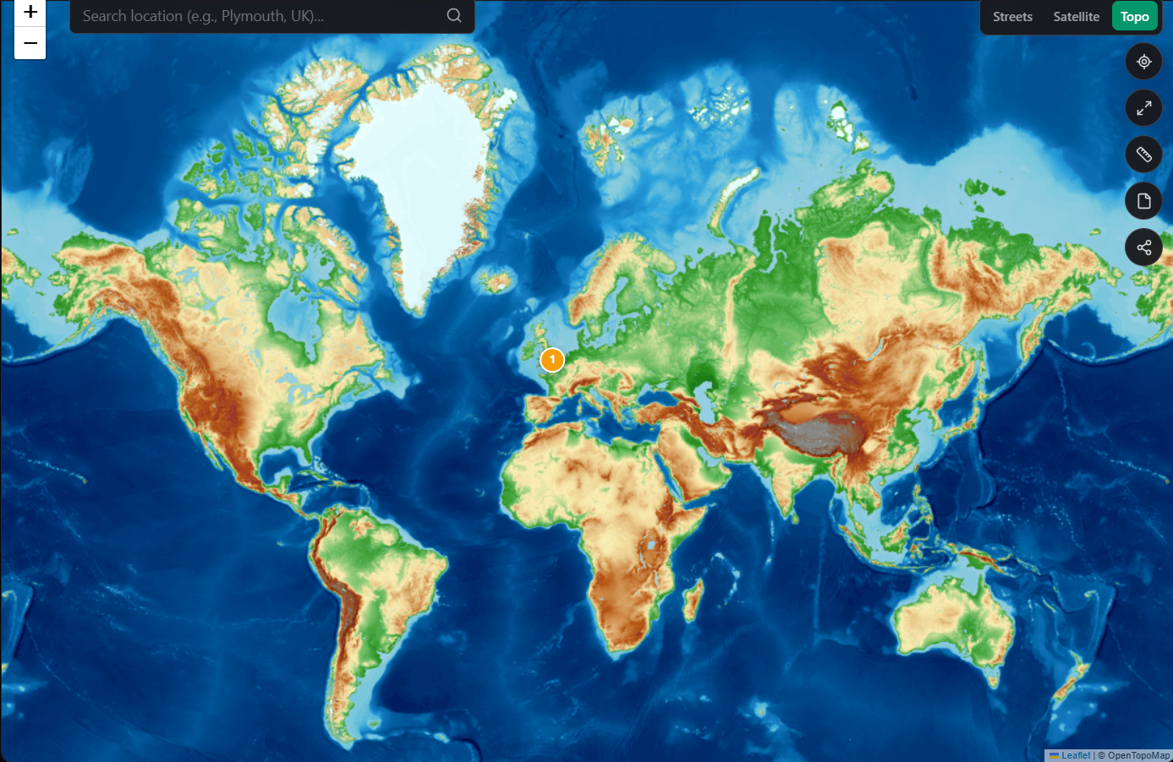

Plotting all cell locations gives the following:
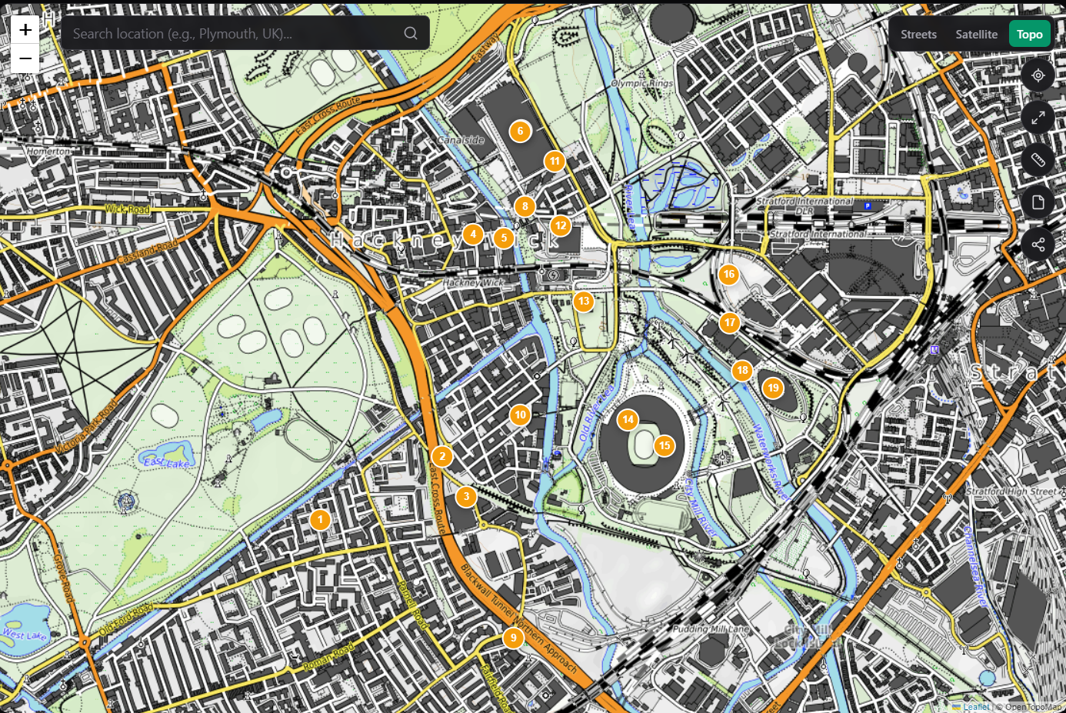

The above diagram shows the cell locations plotted using easting and northing coordinates.

This aligns with the Latitude and Longitude coordinates:
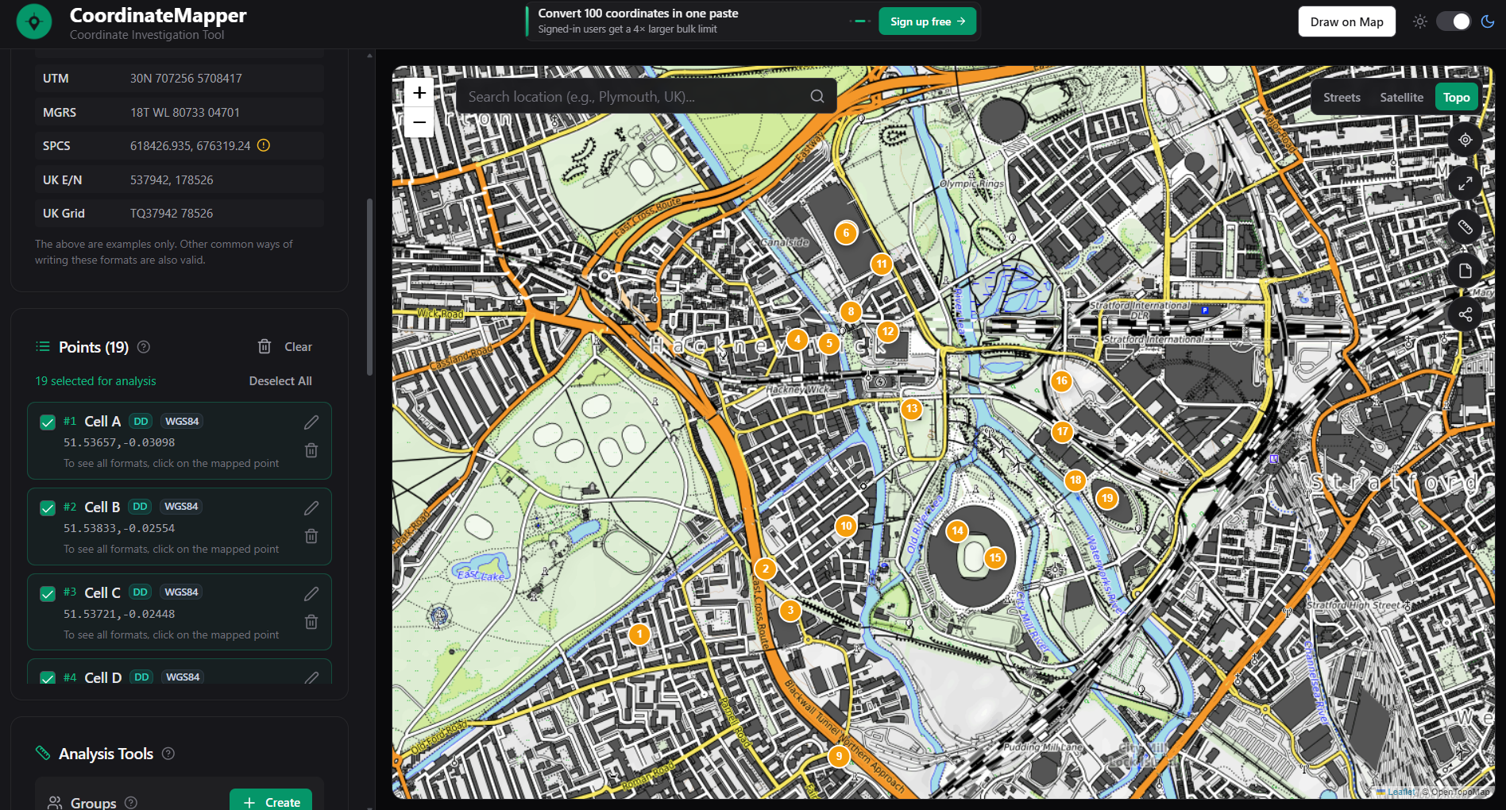

- Frequency Allocation for Cellular Sites
Frequency allocation refers to the assignment of frequencies to cells that avoids interference between them. The same frequencies must be reused across different geographical locations so that many users are served with a limited spectrum.

By applying this understanding to the cell sites provided, this means that frequencies that are close together needs to have their own frequency.

Example filled in using circles denoting area of frequency coverage:
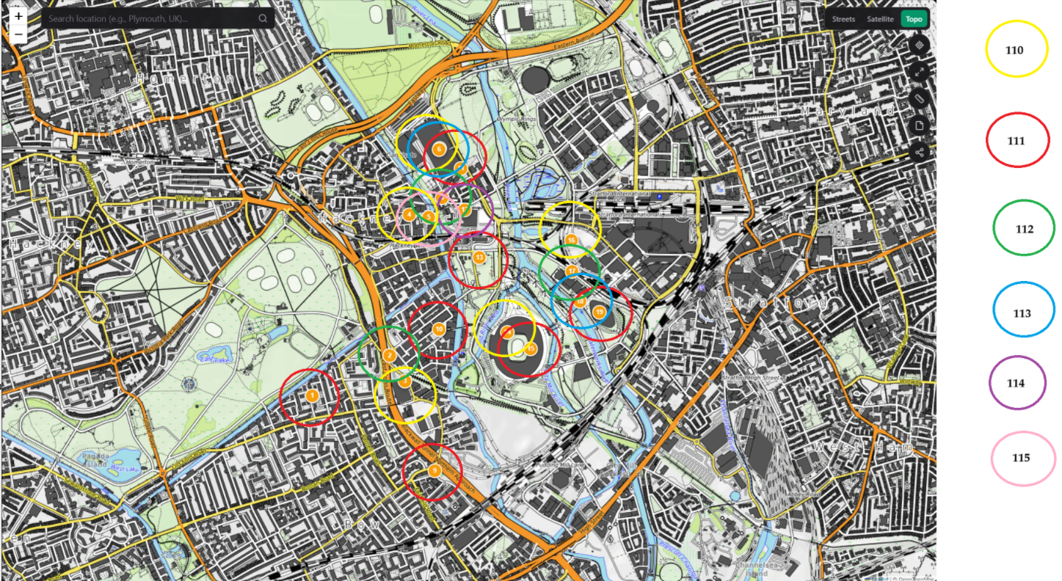

The above diagram shows that certain cells are located far enough away from each other that signals can be reused such as 110 and 111. Some cells are far too close for reusing and thus require their own signal. This is prevalent in cell areas of 4, 5, 6, 7, 8, 11, and 12 as well as areas of 16, 17, 18, and 19 but areas 16, 17, 18, and 19 are far away from cluster 4, 5, 6, 7, 8, 11, and 12 that each one can acquire their own frequency.

From viewing the above diagram, I foresee a challenge in assigning frequencies in cluster 4, 5, 6, 7, 8, 11, and 12 since there are only 6 frequencies to choose from. My approach for this situation is to select a frequency that has already been used but further from nearest location, as e.g shows for cells 4 and 6 both belong to 110 as they are just outside the range.

This exercise has made me aware of the following questions:
What distance can I use as a threshold in which a cell will require a new frequency?
How to determine which frequencies have been used for cells that are close?
If there are more cells, will 6 frequencies be enough?

- Interference due to geographical locations
Interference occurs when overlapping frequencies are placed in close proximity to each other, example Cell F and G are almost on top of each other, this means by giving Cell F and G the same frequency will result in interference.

- Frequency reused
By assigning separated cells the same frequencies, it keeps costs low and spectrum usage efficient. This means that when scaling the network, costs can be kept low since no new frequencies need to be setup with the corresponding configurations.

- Different lists of cell IDs
This tells me that the solution should not be hardcoded to work for the list provided but any list. If a list of 50 cells are given, the program should not crash.

- Calculating proximity using Easting/Northing or Latitude/Longitude
Easting/Northing is used in calculations where there is not much distortion, so for regional analysis. Latitude/Longitude is used for global mapping where curvature has an effect on distance at that scale.

For this assessment, a faster process would be to implement the Pythagorean Theorem using the Easting/Northing, given the cells located in one area and not spread over countries.

Chosen Approach and Algorithm

Chosen Approach
Based on the research performed and problem statement broken down and analysed, I have come up with the following approach.
Following the Input Processing Output template.
The Input
A requirement is that any list of cells should work, meaning I cannot hardcode the data into the program. I will need to implement file parsing logic that will be able to read data from a CSV file that contains the cell IDs and Easting/Northing values.
Processing
Processing the data requires atleast 3 parts:
- Calculate distances using Pythagorean Theorem for each cell pair.
E.g 4 cells A,B,C,D: Calculate AB, AC, AD, then BC, BD, Then CD, so this is a combination of using two options where AB is equal to BA. Using formula: $n_{Cr}= \frac{n!}{r!\left(n-r\right)!}$ Where n = number of options, r = combinations of size r. using this for the assessment: $19c_{2}=\frac{19!}{2!(17!)}= \frac{19 ∙ 18 ∙17!}{2 ∙ (17!)}$ = 171 combinations.
Cell A will contain 18 values from A B then to C till S.
Cell B will contain 17 values from B C, then to D till S.
- Calculate conflicts for each cell by using a threshold and distance value calculated.
Example if Cell ACell B distance array is 430m which is less than 500m (threshold) then Cell A conflict graph will contain Cell B and simultaneously Cell A will get added to Cell B’s conflict graph.
- Assign Frequencies to Cells by using each cells conflict graph as the program loops through cells.
Start at Cell A, assign lowest frequency to cell A which is 110 if no frequency assigned.
Check conflict which is Cell B and Cell C, so Cell B gets 111 and Cell C gets 111.
At this stage both Cell B and C are different from Cell A.
Then I check Cell B which has a frequency of 111, and has one conflict of Cell C.
If Cell B Frequency equals Cell C frequency then Cell C gets 112.

Start at Cell A
If no frequency assign Base Frequency
Run through conflicts until Cell A Frequency does not equal to conflicts frequency by incrementing Cell A frequency.
Run through conflicts again if frequency changed.
Next Cell.

Key point is that we will always start assigning from frequency 110 which is the lowest frequency available and move up by incrementing “Base Frequency”.
By the end of the frequency assignment process all 19 cells should have values that do not interfere with each other.
Output
Each cell will have a frequency assigned that does not interfere with other cells in close proximity.
Output list of each cell with the corresponding frequency.

Algorithm
The algorithm I based my implementation for this 19 cell data set is the Greedy Colouring Algorithm.
It will process the cells in order of input and assign the lowest frequencies.

Alternatives
Algorithm | Ordering Strategy | Key Idea
Largest-First (LF) | Descending Degree | Sorts by the number of conflicts. Most constrained first.
DSATUR (Degree of Saturation) | Dynamic Saturation Degree | At each step, selects the unallocated cell that has the highest saturation (Number of distinct frequencies used by its neighbours). Ties are broken arbitrarily or by largest degree in cluster.

Assumptions
Based on the exercise of manually assigning frequencies to cell sites, I realised I need to decide on a threshold that will determine if cell sites are conflicting and then assign a new frequency.
Based on the area of the cell sites given in this assessment, the threshold for conflict is assumed to be 500 meters to cover an urban area.
Given the size of the area to allocate, the Easting/Northing dataset will be used to calculate the conflict distance value. The Pythagorean formula used: $Distance= \sqrt{∆E^{2}+{∆N}^{2}}$

Efficiency Testing
Threshold of 500 meters:
Metric | What It Measures | Value Achieved
Conflicts remaining | Did any conflicting pair share a frequency? | 1
Frequencies used | How many of the 6 available were needed? | All 6 used
Frequency balance | How evenly distributed are cells across frequencies? | 110 – 5 times  111 – 3 times  112 – 4 times  113 – 2 times  114 – 2 times  115 – 2 times
Reuse distance | Minimum distance between two cells using the same frequency | 500m
Runtime | How long the algorithm takes | 0.0426477 seconds

Threshold of 200 meters:
Metric | What It Measures | Value Achieved
Conflicts remaining | Did any conflicting pair share a frequency? | 0
Frequencies used | How many of the 6 available were needed? | 4
Frequency balance | How evenly distributed are cells across frequencies? | 110 – 11 times  111 – 6 times  112 – 1 times  113 – 1 times  114 – 0 times  115 – 0 times
Reuse distance | Minimum distance between two cells using the same frequency | 200m
Runtime | How long the algorithm takes | 0.0274835 seconds

Threshold of 1000 meters:
Metric | What It Measures | Value Achieved
Conflicts remaining | Did any conflicting pair share a frequency? | 8
Frequencies used | How many of the 6 available were needed? | 6
Frequency balance | How evenly distributed are cells across frequencies? | 110 – 3 times  111 – 2 times  112 – 2 times  113 – 2 times  114 – 1 times  115 – 1 times
Reuse distance | Minimum distance between two cells using the same frequency | 1000m
Runtime | How long the algorithm takes | 0.0567593 seconds

Limitations
Key
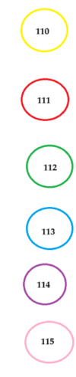
The following results are drawn onto cell site positions, Black rings denote no frequency allocated due to conflicts.
The following shows results based in a 500 meter threshold:
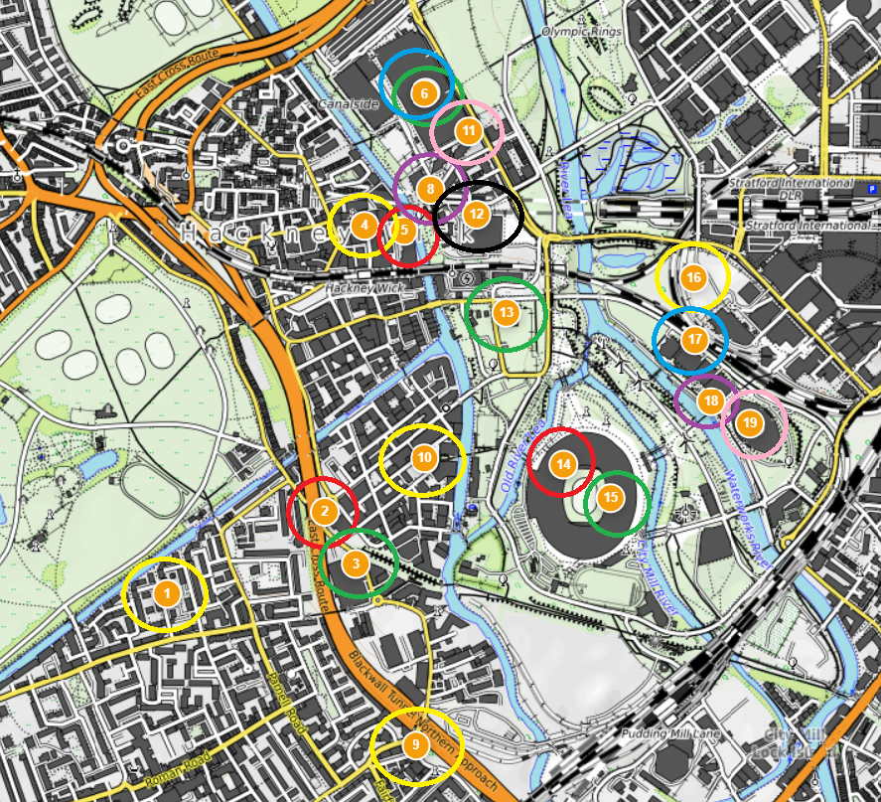
The following shows a 200 meter threshold:
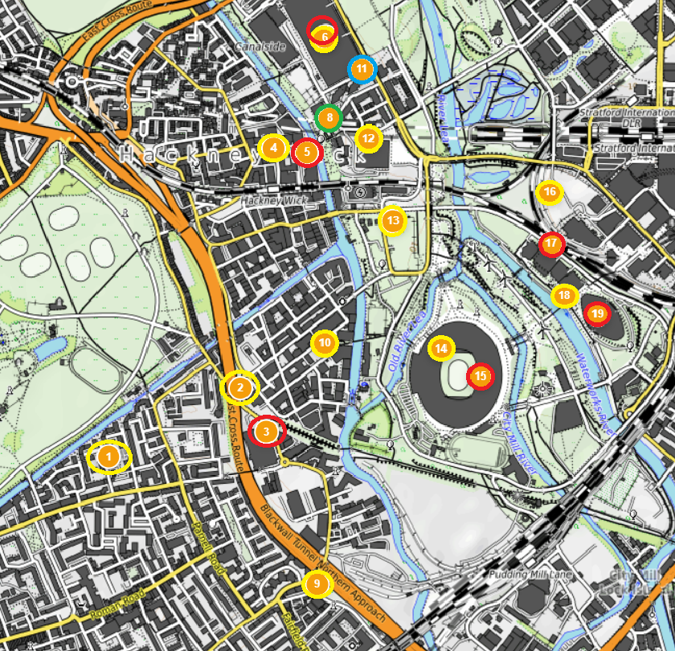
The following shows a 1000 meter threshold:
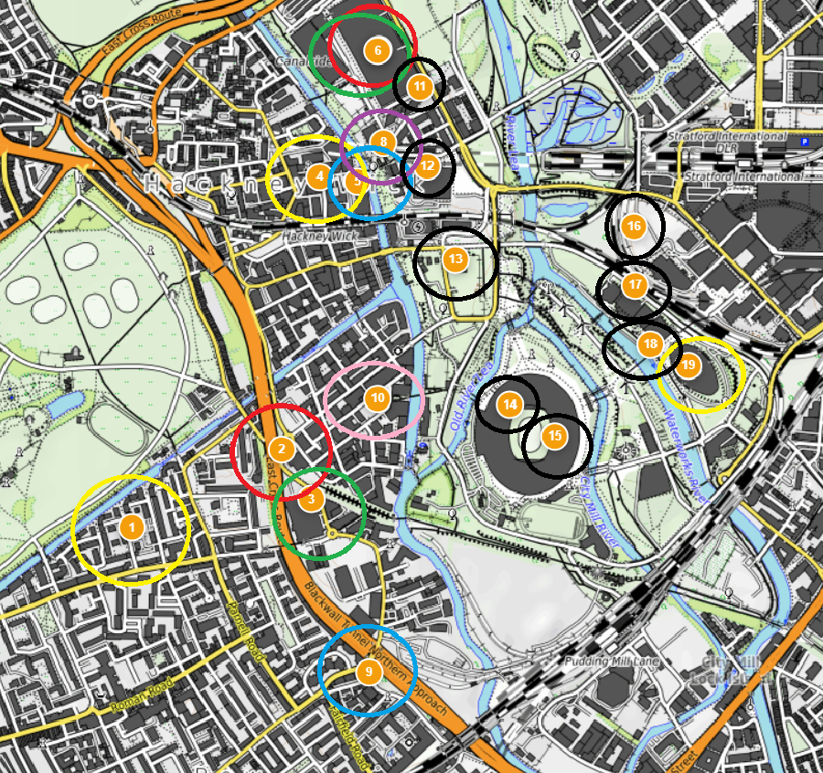

The above testing shows that the limitation of this algorithm is the conflict distance, which needs to be a small distance that is less than 500 meters for this assessment.
Another limitation is the speed of processing, 19 cells take less than a second, 50 cells take ~0,1 seconds and a 1000 cells takes ~33 seconds.

Improvements for Larger Networks
Based on testing that was done on this algorithm, a key factor that determines processing speed is the threshold distance, shorter distance means faster processing.
The algorithm processes cells naively which means a more lenient conflict distance needs to be considered. For larger networks, meaning more cells, the currently algorithm can handle 1000 cells at 200m but takes roughly 33 seconds. The key factor is the conflict distance is 200 meters which is quite small.
For significantly larger networks that covers more distance, the DSATUR algorithm should be implemented that handles the clusters that has the highest saturation, this way the highly dense clusters get assigned frequencies and can be reused in the sparse clusters.

AI Usage
AI has been used to complete this assessment.
I have used DeepSeek to ask questions to improve understanding of assessment and industry.
Below are some example prompts:
“Tell me more about frequency allocation”
“Im doing my research doc so far. A key question came to me. How do I know which frequency was used for a cell and how do I know not to use that same frequency again?”
“What is DSATUR”
“Wait, You mentioned a conflict graph, how will I know which cells are conflicting?”
“Then once I have the conflict graph, run through each cell and check if it has a conflict if it does, assign it a frequency. How will i know that the frequency I am assigning is the correct one”
“i havent learnt about reading from files in C# as yet”
“What is the permuation formula for determining Cell A with other cells then Cell B”
“Ive got my process into the following steps:
1) Get input from csv file
2) Caluclate distances
3) Calculate conflicts
4) Assign frequencies to cells
I know that a conflict means a new frequency needs to be assigned, If i assign Cell A 110 and B and C conflict with A then that means i assign Cell B 111 and Cell C 112.”
“So i wll give cell A 110, cell B 111 and cell c 111 if i loop through cells and check each cells conflict graph”
“Give me the algorithms that are in the same class as my greedy coloring algorithm because i want to research alternatives”
“Give me the algorithms that are in the same class as my greedy coloring algorithm because i want to research alternatives”
“what is degree in DSATUR”
“Is 500m a good threshold for conflicts in this region? and why?”

